**A9Wi Partial autocorrelation function (PACF)**

If correlation measures association between two variables, what happens if we have more than two variables? In this case we can calculate partial correlation. Effectively, the partial correlation coefficient keeps the variation of one variable constant, whilst measuring the relationship between the other two. In other words, we can “exclude” the effects of one variable when measuring the relationship between the two other variables.

Just as we have extended the correlation concept to autocorrelation, we can extend the concept of partial correlation to partial autocorrelation. If autocorrelation measures association between the time series and its previous lagged values, then partial autocorrelation does the same, but by keeping the influences of all other lags constant. How do we calculate the partial autocorrelation coefficients? For the first lag it is easy to calculate the first partial autocorrelation as it is equal to the first autocorrelation, i.e. for k=1:

p1.1 = r1 (1)

For a number of lags greater than 1:

For k=2,3,.....L pk.k =  (2)

Where:

For j=1,2,...,k-1 pk.j = pk-1.j – pk.k pk-1.k-j (3)

In other words, to calculate p2.2, the second partial autocorrelation, we have to use the equation (2):

p2.2= 

However, in order to calculate p3.3 we first have to calculate p2.1, which is done by applying equation (3):

p2.1 = p1.1 – p2.2 p1.1

To expand this example, to calculate the partial autocorrelations, for example for periods 3 to 6, we use the following equations:

p3.3= 

p4.4= 

p5.5= 

p6.6= 

In order to calculate these partial autocorrelations, in between each of them we have to make the following calculations:

p3.1 = p2.1 – p3.3 p2.2

p3.2 = p2.2 – p3.3 p2.1

p4.1 = p3.1 – p4.4 p3.3

p4.2 = p3.2 – p4.4 p3.2

p4.3 = p3.3 – p4.4 p3.1, etc.

And finally, for p6.6 the same calculations would include:

P6.1 = p5.1 – p6.6 p5.5

P6.2 = p5.2 – p6.6 p5.4

P6.3 = p5.3 – p6.6 p5.3

P6.4 = p5.4 – p6.6 p5.2

P6.5 = p5.5 – p6.6 p5.1

**Example**

In this example, we will again use the full set of UK visits abroad, as in textbook. From the example we will just copy the values of autocorrelation coefficients and start calculating the partial autocorrelation coefficients. As it is very time consuming to calculate partial autocorrelations in this way, we will only show the first 12 PACF.

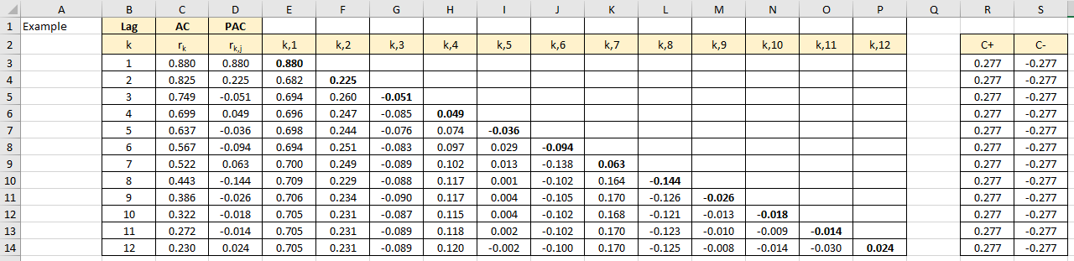

Figure 1

**Excel solution for the calculation of SE and CI’s**

Lag Cells B3:B14 Values

ACF Cells C3:C14 Copy from Figure W8.7 cells E3:E15

PACF Cells D3:D14 Copy of the cells E3, F4, G5, H6, …, P14

Partial coeff. Cells E3:P14 See the formulae in spreadsheet.

SE Cell F3 Formula: =1/SQRT(COUNT($C$3:$C$52))

+ CI Cell R3 Formula: =1.96*1/SQRT(50)

Copy formula down R4:R14

-CI Cell S3 Formula: =-1.96*1/SQRT(50)

Copy formula down S4:S14

The formulae in the section E3:P14 correspond to equations (2) and (3), and the corresponding examples that follow. There are much easier ways to calculate PACF in Excel, but for the purposes of understanding how these coefficients were calculated, this complex method will suffice for the time being.

Let’s look at the graph containing PACFs (Figure 2).

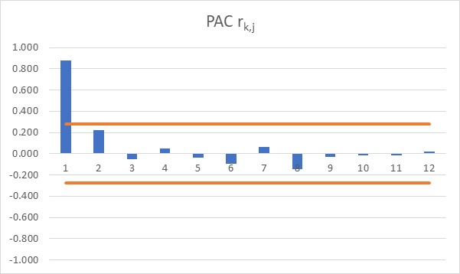

Figure 2

The graph shows that only one partial autocorrelation is non-zero, whilst all the others can be equal to zero. When compared with the graph for autocorrelations, the ACFs show persistent non-zero values for up to the 11th coefficient. What is the meaning of that? This is a brand new topic beyond the scope of this book.